Pureinsights – Snowflake integration automation scenario

1. Global run.

* Global run triggered by: LaunchUFT_PI_vs_SF_Metadata_Data_Verification

For each project we have to update first line URL:



* Global run controlled by: GlobalDataSheet_PI_vs_SF_Metadata_Data_Verification

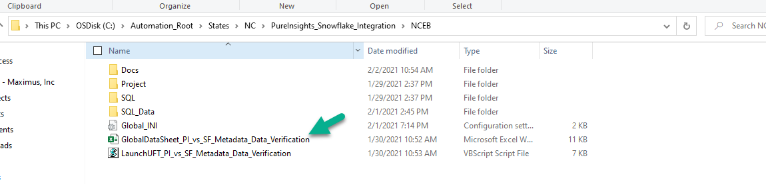

* Three scripts cover full run:

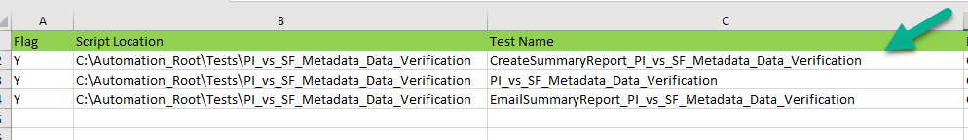

1. First script: **CreateSummaryReport_PI_vs_SF_Metadata_Data_Verification**
2. Create main folder PI_vs_SF_Metadata_Data_Verification under C:\Maximus\Reports.
3. If folder already exists, we rename previous one with timestamp, folder was originally created.
4. Created SummaryReport_2021-02-01 file.
5. Second script: **PI_vs_SF_Metadata_Data_Verification**